David Williams
1625 Yarmouth Avenue
Boulder, CO 80304
720-308-0915
danjo53@gmail.com
http://realdavidwilliams.com/ (website of creative works)

http://www.colorado.edu/cye/people/research-affiliates/david-williams

Community Engagement, Design and Research (CEDaR) Resource Center

UNIVERSITY OF COLORADO BOULDER
Top of Form
David Williams
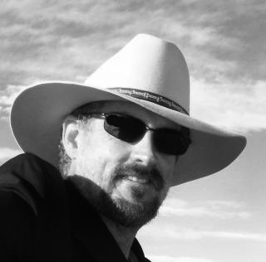
David Williams

Writer, Songwriter, Artist, Scholar
David Williams is interdisciplinary scholar and artist who works in a variety of genres, for BOTH children and adults. An Emmy winning songwriter, his songs have had over 80 million hits on YouTube, and he is currently represented in Hollywood as a songwriter and screenwriter for TV and Film. Also a children's author with Random House, David has been teaching the lessons of wildlife preservation and sustainability to new generations. From the book about his grandmother--which is in the McGraw-Hill 5th grade textbook (Grandma Essie's Covered Wagon), to his Rhino Song (which is being used in anti-poaching education in South Africa, having been taught to over 100,000 young people)--David has impacted people all over--awakening them to the sanctity of the natural world.
David has also published fiction, non-fiction, poetry, cartoons (with the Chronicle of Higher Ed and other publications), and is an established painter; he is also a multi-instrumentalist specializing in gypsy jazz, blues, and americana. Over the years he has released numerous award-winning CDs of original songs. A new CD of songs for adults was recently released that hit 22 on the Indie Charts in 2015: Little Prayers of Belief. David has been a writer in residence at many colleges and universities in the US. His most recent scholarly work is The Trickster Brain, about neuroscience and literature, and how biology is implicated in our story making selves.
Science Writer—Neuroscience, Anthropology, and Literature
His latest adult book, The Trickster Brain: Neuroscience, Evolution, and Narrative, examines the evolution of the brain and the development of stories while dealing with numerous other areas that define our biological selves. In this book, mythology is examined as a window into the brain's modular construction.

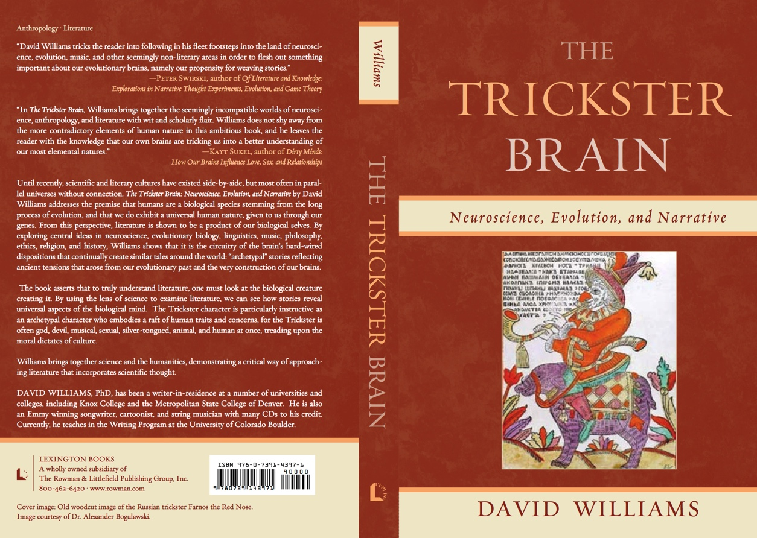

EDUCATION

University of Illinois at Chicago—Ph.D. in English/
Dept. of English / Creative Writing (Dec.1993) Specialization: Fiction Writing, under the direction of Michael Anania. Literature Specialization: Native American Literature, under the direction of Dr. A. LaVonne Brown Ruoff
Northern Illinois University—M.A. English
Dept. of English Literature, 1984. Specialization: Creative Writing, Poetry, under the direction of Lucien Stryk
Northern Illinois University—B.A. Anthropology, 1978
University of Iowa—Post-graduate study in Anthropology, 1980-81

RECENT WORK AND PROJECTS

The South African Children’s Endangered Animal Music Project
As the number of rhinos, elephants, lions, and other large mammals plummeted over the last few years due to increases in poaching, a few independent international projects to protect wildlife began and eventually converged, which led to the formation of The South African Children’s Endangered Animal Music Project, to expand the message of wildlife protection to kids in Africa, and beyond.
In 2011, Irene Huysamen, Chairperson of the Green Wall of Africa, managed the “Rights for Rhinos,” program www.rightsforrhinos.co.za in which two game rangers walked 2,000 kilometers, educating children about the plight of rhinos and other animals. They spoke to over 16, 500 school kids on the main route and at the end of the 3 month journey realized that the South African youth had little to ZERO knowledge about what was happening to their heritage, in particular the rhino! It was decided by the team that they needed to start their own non-profit organization (Green Wall of Africa SEE Projects) as a platform for the youth of South Africa to have a “VOICE” for the “VOICELESS” and in June 2012 they launched the youth project “Rhino SA” www.rhinosa.co.za facebook: RHINO SA.
While scouring the Internet for resources to present to children on rhinos, Irene stumbled upon David Williams’ (http://realdavidwilliams.com/) Emmy winning “Rhino Song” (http://youtu.be/QOvIot-i6rY), which had been featured on a PBS show for kids called Big Green Rabbit. This song became the linchpin in advancing the cause of rhinos, as the video of the song has now been shown to over 100,000 kids in South Africa, carried from location to location via computer and screen, stirring excitement, as the program has enlarged to children becoming “rhinos” themselves, complete with authentic badges, designating them as protectors of wildlife https://www.facebook.com/photo.php?v=4595853554095.
SCREENWRITING
Currently writing and pursuing movie and TV deals, including two feature films, The End of Animals, and Manoir De Mes Reves, as well as a number of sitcoms: Matches, and The Starless Celebs Club, Creako & Cleopatra, The Secret Gospel, and more.

GRAPHIC RECORDER/FACILITATOR/SCRIBE, VISUAL ARTIST
Worked for companies such as Educause, McKesson, and AT&T doing Graphic Recording. 2005-2009 Cartoonist and Graphic Recorder for ECAR/EDUCAUSE, an international think tank for Higher Education—the New Hampshire Symposium on Higher Education sponsored in part by Hewlett Packard, July 2005; the San Diego Symposium, June 200; the Phoenix Symposium, December 2006; and the Boulder Symposium, 2007.

2009 EMMY WINNER, TELEVISION, WRITER, SONGWRITER, for writing & composing for Big Green Rabbit, an environmental TV show for children that taught sustainability and respect for the environment, which ran nationally for two years on PBS. Produced videos of my work about nature, wildlife, and ecological stewardship have had over 30 million hits on YouTube. Currently working on a new show, Animalooza, which will appear on Rocky Mountain PBS in October, 2013, all songs written by David Williams.

ONLINE EDUCATION WRITER, RESEARCHER, DEVELOPER for CU Boulder Continuing Education: Designing classes for online instruction, including best practices for teaching online, which involves the production of new digital techniques for online education, and helping to develop techniques for a new online writing center for tutoring students at CU.

CARTOONIST/VISUAL ARTIST
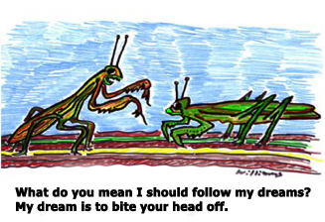
Long-time cartoonist for Chronicle of Higher Education, Barrons, and other magazines and newspapers as well as cartoon cards with Carlton Cards and Soultrader of London. See “Cartoons” at http://realdavidwilliams.com/.

PLAYWRIGHT
Developed Science/Literature/Music/Ecological Sustainability curriculum and classes bringing the Humanities and Arts together, through over 15 years of residencies through the Illinois, Iowa, and Missouri Arts Councils’ Artist in the Schools Program as well as The Rockford Arts Program, and STEM schools in Colorado. This included creation of songs, poetry, plays, and short stories, most of which focused on scientific exploration of nature and ecology interpreted through art. Environmental Play for Colorado Stem Schools, written in 2011, “Going Down the River,” which led to receiving 2011 Encompass Research In China Cultural Exchange Travel Grant.

Artist-in-Residence Writer, Composer, and Videographer at Wild Bear Nature Center, Nederland, CO, summer 2010, 2011, creating videos and songs for the web having to do with Colorado wildlife, ecology, and sustainability. Published CD of original songs for kids on sustainability and ecology: Wild Bear Nature http://www.dailycamera.com/ci_16875901.

BOOKS
The Trickster Brain: Neuroscience, Evolution, and Narrative, published June 2012, published by Rowman & Littlefield Publishing Group. This book deals with recent findings in neuroscience, evolutionary psychology, but it is also a primer on how to take a cognitive critical approach to literature (bringing science into the humanities), which requires knowledge of human evolution, biology, the development of music, and art in our species, gender, sexuality, religion, and more. Worldwide trickster stories from myth and literature are used to as a window into our biological selves and our constantly conflicted brains, which were never designed but developed in the haphazard process of natural and sexual selection.
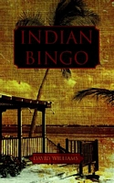
2006 Indian Bingo. Ghost Road Press. A collection of short fiction stories with an accompanying CD of 18 original songs titled Joplin, MO. Indian Bingo was a finalist for the Drue Heinz Prize, and two of the stories received awards from the Illinois Arts Council.

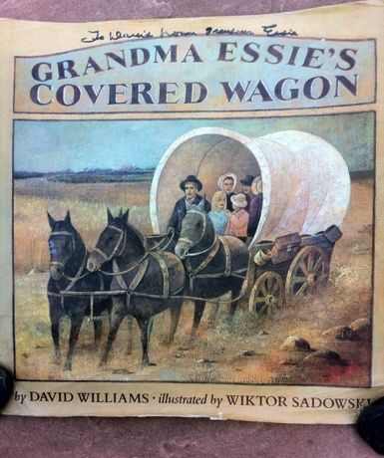
1993 Grandma Essie's Covered Wagon.
Alfred A. Knopf. A juvenile book about the early life story of Essie Williams, chronicling her travels in a covered wagon with her family through economically distressed Kansas, Oklahoma, and Missouri, shortly after the turn of the century. 1994 Notable Award Winner from the National Council of Social Studies. Reviewed in Publishers Weekly July 12, 1993, The Bulletin of the Center For Children's Books, October, 1993, and The Horn Book Magazine, November, 1993. Note: This book is also included in a two fifth grade reader anthologies: MacMillan Co. and McGraw Hill, and is part of the school curriculum for millions of American children.

1990 Walking to the Creek.
Alfred A. Knopf. A juvenile book about the exploration of a small pasture creek by two boys who discover ecological destruction yet also the beauty of the natural environment. Reviewed in Newsweek, December 3, 1990: 65 as one of the top twenty children’s books of the year. Reviewed in Booklist December 15, 1990: 863.

1997 What Do I Read Next: Multicultural Literature: Section on Native American Literature.
Rafaela G. Castro. Edith Maureen Fisher, Ph.D. Terry Hong. David Williams.
Ph.D. Detroit: Gale Research Publishing Co. 1997. (Wrote the one fourth of this book on Multicultural Literature dealing with Native American Literature. The book is an annotated bibliography with an extensive introductory essay).

PUBLICATIONS IN LITERARY MAGAZINES

Short Stories

2002 ”Don’t You Know That?” Element magazine issue 3, vol. 1, April, 27-29.
2002 "Bobby Angel," TriQuarterly issue 113, Summer 213-217.
1993 "Next Door Neighbors," Farmer's Market 10 91-97.
1992 "Hello From the Heartland," The Writer's Barbecue 7 66-92.
1990 "Nerves," Karamu 12.1 (Spring): 51-54.
1990 "Thicker Than Water," Farmer's Market 7.2 33-46.
1990 "Mound," Wapsipinicon Almanac 3 74-78.
1989 "Fishing," Other Voices 9 (Spring 1989): 67-175.
1989 "Spook Light," The Beloit Fiction Journal 4.2 7-14.
1989 "Animals," Black River Review 5 3-4.
1989 "Gizzards," Farmer's Market 5.1 7-18.
1988 "Langston Hughes," Webster Review 13.2 52.
1988 "Key Lime Pie," Farmer's Market 4.1 70-77.
1987 "Country Music," The Chariton Review 13.2 38-48.
1987 "Indian Bingo," Farmer's Market 4.1 43-51.
1987 "Brothers," Cimarron Review 78 17-21.
1986 "A Good Policy," The Beloit Fiction Journal 2.1 81-89.

POEMS
1987 "Bush," Passages North 8.1 8.
1987 "Late Season," Sunrust 8 (Winter): 26.
1987 "Cob," The Phoenix 6. 1 & 2 67-68.
1987 "The Cows," Pacific Review 5 52.
1987 "Buzzell Road," Sunrust 8 (Winter): 32.
1986 "White Fish," Calliope 9.2 (May): 43.
1987 "White Fish," Food for Thought. Bigby, Joan & John., ed. New
York: William Morrow & Co. (1987): 250.
1987 "Listening to Guy Dull Knife Sing," The Midwest Quarterly 28.3
1986 "Alphabet," Poets On 10.1 (Winter): 13.
1986 "With Kelly Along the Creek," Poets On 10.2 (Summer): 38.
1986 "Owl," The Rectangle 61.1 33.
1985 "Plant Food," Poets On 9.1 32.
1985 "Osprey," Black Bear 2 37.
THEATRE
2011 Going Down the River, a musical for kids about sustainability.
2009 DJANGO A full length musical about Django Reinhardt, the French gypsy guitarist who died in1953.
1997 Cliques. A full length musical for young adults, produced by New American Theatre. Rockford, IL.
1994 Two Fairy Tales. Music and Lyrics of a children’s play, produced by the Springfield Theater Center.
1991 Oh, The Animals. A full length musical play for children, produced by Mid-America Playwrights, Theater Company.

FILM & VIDEO DOCUMENTARIES
2012 The Human Story, a 20 minute documentary on the rise of our species. http://youtu.be/YeVC3Q5E-kU
2002 I Love English in a Major Way, a 30 minute mockumentary on being an English major, written and directed in conjunction with some of the students in the Ink Stained Wretches writer’s group based in the English Department at MSCD. The movie was produced and filmed by the Auraria Media Center.
http://video.google.com/videoplay?docid=-4741263325594951110

MUSIC

Singer-songwriter, Folk, Blues, & Swing historian, multi-instrumentalist, specializing in americana music and Gypsy Jazz guitar.

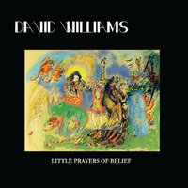
CD ALBUMS
2015 LITTLE PRAYERS OF BELIEF. 13 new songs by David Williams—folk, blues, gypsy jazz.
2011 Chocolate Bar. 14 new songs by David Williams, folk, americana.
2011 Wild Bear Nature. 21 new songs for kids by David Williams. Review: http://www.dailycamera.com/ci_16875901
2010 The Crazy Kind. 15 new songs by David Williams, Americana/bluegrass/folk, featuring David on guitar and vocals, Kristina Murray on guitar and vocals, Jordan Ramsey on mandolin, Katie Glassman on fiddle, Duane Webster on bass, and Chris Elliott on banjo. Reviews at http://realdavidwilliams.com/.
2007 Django Jazz. 17 songs in the Gypsy Jazz genre, with Deco Django.
2006 Joplin, Mo. A compilation of original songs that act as a companion CD to the book of short stories, Indian Bingo. The songs are in the old-timey and country blues vein and feature the Americana singer, Darcy Perez, on many of the vocals. The album reflects the characters and landscape of the Ozarks. See http://realdavidwilliams.com/ for reviews.
2005 David Williams and Deco Django. A live recording of tunes from the gypsy jazz repertoire in the style of the original Hot Club of Paris, first developed by the great Django Reinhardt and Stephane Grappelli. David Williams on lead guitar, Bill Pontarelli on clarinet, Jerry Rudy on rhythm guitar, and Duane Webster on standup bass. See www.decodjango.com for reviews.
2003 Where the Dark Road Starts: Songs of Love.
Studio recording done at Swallow Hill’s famed studio in Denver, featuring all original compositions in a folk, blues, gypsy jazz vein. See http://realdavidwilliams.com/ for reviews.
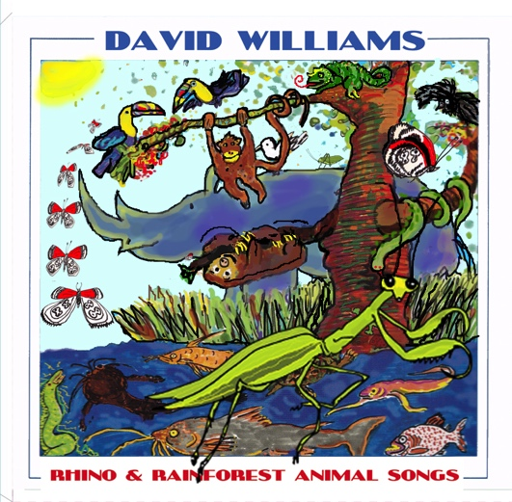
2003 Rainforest and Tropical Animals. A collection of original animals songs, many of which were commissioned by Chicago's Shedd Aquarium for their "Tropical Rising Exhibit. Winner of a 2003 NAPPA Award. See http://realdavidwilliams.com/ for reviews.
1995 Route 66. Fifteen original art songs about people and places along the old Route 66 highway: blues, folk, and jazz melodies, recorded with a grant from the Illinois Arts Council in music composition. Reviewed in the Chicago Sun Times Sept. 23, 1994; in The Maverick Report in October 1994; in Dirty Linen, August 1994; in the Icon, October 1994; in The 66 News, Summer 1994, and Route 66 Magazine in Spring 1994. Featured as a news story on nationwide on National Public Radio and internationally on Monitor Radio, Spring 1994. See www.trapdoor-media for reviews.
1990 Oh, The Animals. An American Library Association award winner, fourteen original songs for children. Reviewed in Booklist December 15, 1990: 873. Reviewed in The Chicago Tribune Sunday, August 19, 1990: Tempo Section 3. Reviewed in Dirty Linen February--March 1991:51. Reviewed in The Chicago Sun Times June 21, 1991: 46. See www.trapdoor-media for reviews.
1990 Peach Faced Love Bird. Seventeen original songs about endangered species from around the world, featuring calypso, blues, folk, and jazz music. Reviewed in Dirty Linen December, 1992.
1985 Cowboy Time. Recorded with help from a grant by the Illinois Arts Council, original Western songs covering the historical range of cowboy music.
1981 The Great Frontier. Original folk songs, with a Midwestern theme.

AWARDS & GRANTS
2011 Recipient of 2011 Encompass Research In China Cultural Exchange Travel Grant: Traveled two weeks throughout China, summer 2011, all expenses paid, to meet with students from grade school to college, teaching environmental songs and learning about Chinese music and culture.
2009 Emmy winner in Composition and Writing for work on The Big Green Rabbit, PBS television program (for which I wrote most of the songs for the series).
2008 Band winner Denver Post Theater Awards for best musical band in Colorado for “Woody Guthrie’s American Song,” which was part of the 2008 Colorado Shakespeare Festival.
2008 Emmy Nomination in Songwriting for the PBS childrens’ show, Big Green Rabbit.
2002-2003 National Association of Parenting Publications Award, NAPPA, for children’s music, for the album Rainforest and Tropical Animals.
2000 Grant from MSCD for writing time in the summer months, $3,000. This grant allowed me to begin work on a collection of short fiction.
1997 Award of $500.00 from the Illinois Arts Council in music composition,
performance (vocals, guitar, violin, & mandolin), and songwriting for Who Let That Django Jazz Into the Room?
1995-1996 Included in the "State of Illinois Authors Poster," presented by the State of Illinois, honoring 113 Illinois authors, past and present who have made a contribution to American literature.
1994 Designated as a participant in the 1995-1996 Arts-Tour Program through the
Illinois Arts Council. The Arts Council will pay for twenty-five percent of the fees for all public appearances by David Williams made in the State of Illinois over the next two years.
1994 Artist Assistant Grant for promotion of the CD Route 66, from the Illinois Arts Council: $500.00
1993 Award in Song Writing for Route 66, from the Springfield Area Arts Council, in conjunction with the Illinois Arts Council, and the National Endowment for the Arts: $500.00.
1992 Award in Literature for the short story, "A Living That Means Something," from
the Springfield Area Arts Council, in conjunction with the Illinois Arts Council, and the National Endowment for the Arts: $500.00.
1991 Grant from GTE for a production of the play Oh, The Animals at the Egyptian
Theatre in DeKalb, Illinois, $1,500.00.
1991 Literature award in the short story from the Illinois Arts Council for "Nerves,"
which appeared in Karamu, $1,000.00.
1991 Notable Award in Children's Music, the top audio honor from the American
Library Association (the organization which confers the Caldecott and Newberry Awards) for Oh, The Animals a cassette tape of fourteen original songs, on Trapdoor Records.
1991 Illinois Arts Council's Illinois: The State of Writing Reading Series award winner.
Chosen as one of twelve Illinois fiction writers and poets to read in the first official state sponsored reading series.
1987 Literature award from the Illinois Arts Council in the short story for "Indian
Bingo," which appeared in Farmer's Market, $1,000.00.
1987 A collection of short stories, The Bingo Bus, was a finalist in the Drue Heinz
fiction competition at the University of Pittsburgh Press.
1986 Judson Q. Owen Prize in Literature, from Sigma Tau Delta, $1,000.00.
1985 J. Hal Connor Award for Creative Prose from Northern Illinois University.
1984 Lucien Stryk Award in Poetry, Northern Illinois University.
1983 Illinois Arts Council Fellowship in Music Composition, $1,000.00.
1978 Folk Music Apprenticeship Grant from the National Endowment for the Arts for
study with a master musician, $1,000.00.

TEACHING EXPERIENCE

2010—Present University of Colorado at Boulder Instructor. Teaching courses in Environmental Writing, Science Writing (Neuroscience), Composition, Business Writing, and Literature.

2007-2010—Colorado School of Mines
Instructor. Taught courses in Nature and Human Values (Ecology, Sustainability, Ethics) for LAIS.

2009, 2010—Artist in Residence at Wild Bear Nature Center, Nederland CO June through August

2005-2007—University of Colorado at Boulder. Instructor. Taught courses in American & British Literature.

1998-2005—Metropolitan State College of Denver. Department of English. Assistant Professor, Director of Fiction Writing. Taught Creative Writing, and American Literature. Official student advisor.
1997-1998—Kishwaukee College. Instructor. Taught Creative Writing.
1994-1998—Northern Illinois University. Instructor. Department of English, Instructor.
1993-1994—Knox College. Department of English, Visiting Assistant Professor of Creative Writing, Artist in Residence. Galesburg, Illinois.
1991-1993—Sangamon State University. Instructor. Department of English, part-time Professor of Writing and Literature. Springfield, Illinois.
1987-1991—The University of Illinois at Chicago. Department of
English, Teaching Assistant. Chicago, Illinois.
1990-1991—Northern Illinois University. Department of English, Teaching Assistant. DeKalb, Illinois.
1984-1998—Illinois Arts Council Artist in Education Program, Artist in Residence.
1984-1987—Iowa Arts Council Artist in Education Program, Artist in Residence.
1984-1987—Missouri Arts Council Artist in Education Program, Artist in Residence. Taught short courses in over a hundred residencies, lasting from one week to two months, in Creative Writing (both poetry and fiction) and Music Composition, at elementary schools, middle schools, and high schools in towns and cities throughout the Midwest. Iowa Arts Council Touring Arts Team member. Conducted two day workshops music and literature, and gave evening performances at dozens of Iowa towns with populations below 1500. University of Iowa.
1980-1981—Department of Anthropology, Research Assistant. Iowa City, Iowa.

COURSES TAUGHT

Environmental Writing
Science Writing
Modern and Contemporary Literature
Nature & Human Values
Introduction to Women’s Literature
Introduction to Shakespeare
Blues Music and Poetry
Senior Writing Experience, Multi-genre Workshop
Advanced Fiction Writing Workshop
Creative Writing Workshop: Fiction
Creative Writing Workshop: Literary Humor
Creative Writing Workshop: Contemporary Short Story
Freshman Composition--101 & 102
Freshman Composition—Online
Freshman Composition—101, with an emphasis in Anthropology
Developmental Writing
The Art & Craft of Writing
Native American Literature
American Literature since 1865
Fiction Writing for Young Adults
Introduction to Creative Writing
Introduction to Fiction
Writing Workshop: Drama for Children

TEACHING AND RESEARCH INTERESTS

Cognitive Science, Evolutionary Psychology, Fiction Writing, Poetry Writing, Native American Literature, Cultural & Physical Anthropology, American Literature, Songwriting & Music Composition, Cartooning, Children’s Literature, Drama, Musical Theater, World Literature, Mythology, Composition, Folk Music, Gypsy Jazz, Blues, Swing, Jazz

A SAMPLE OF ONE YEAR OF COMMUNITY SERVICE

Below is a sample of selected Invited Appearances and Public Service engagements covering the years 2001-2002. A larger schedule of current and past dates is available upon request.

2002 Louisville Recreational Center, Pikes Peak Library, Palmer Library, Davies Library, Parker Library, Mamie Doud, Eisenhower Public Library in Broomfield, Sand Creek Library, Lone Tree Library, Castle Rock Library, Kelver Public Library, Roxborough Library, YMCA of the Rockies, Estes, Light of the World Catholic Parish, Sheridan Public Library, Smoky Hills Public Library, Boulder Public Library.

2001 Guest lecturer for the Lafayette School, Euclid School in Denver for their Fall Literary Festival, a benefit fundraiser (held at Eron Johnson Antiques) that drew a cast of dignitaries from around the world, including the Princess of Yugoslavia, guest speaker at Linsky School in Denver for their Fall Literary Festival, participated in the CLAS conference as a performer at The Broadmoor Hotel for the Colorado Language Arts convention, Lafayette Library, Denver Botanical Gardens, Denver.
2001 The Denver Jazz on Film Festival, the Smithsonian's "The Age of Jazz in Paris" at the Boulder Public Library, Trios in Boulder, Sambuca's in Denver, Trios in Denver, Café Rialto in Denver, the Tattered Cover Bookstore in Denver, the Boulder Creek Festival, the Broomfield, CO Public Library, the Boulder Public Library, Louisville Elementary, The Taste of Louisville, Ft. Madison, IA Public Library, Bettendorf, IA Public Library, Cedar Rapids, IA Public Library, Village Squire in Dundee, IL, St. Charles Public Library, Chicago's Shedd Aquarium, DeKalb, IL Public Library, Park Ridge, IL Public Library, Aurora, IL Park District, Sanctuary in Iowa City, The Louisville, CO Public Library, Des Moines, IA, Public Library System, The Mill in Iowa City, IA, Snowmass children's festival in Aspen, CO, Denver Elementary school on Magnolia, Colorado Language Arts Association presentation at the Broadmoor at Colorado Springs, in collaboration with Rene Ruderman: The Writing of Poetry and Songs.

NPR RADIO APPEARANCES

1988 "Flea Market."
1980 "A Prairie Home Companion."
1979 "All Things Considered."
1979 "Folk Festival USA."

International Folk Festival Appearances

1988 The Vancouver Folk Festival.
1985 The Winnipeg Folk Festival.

TELEVISION APPEARANCES

2008-2010 Featured singer-songwriter on PBS show for kids, Big Green Rabbit, which ran nationally

for two years. Videos from the show are available on YouTube, with over 30 million hits.
1998 Featured as a news special on Denver television, ABC, for a library performance.
1994 Missouri PBS filmed a documentary: David Williams's songs of Route 66
1994 Interviews and news features by the ABC and CBS affiliates in Joplin, MO.
1991 David Williams, Artist in Residence. A video documentary chronicling the teaching of
writing in the Artist-in-Education program was produced in 1991 by Afterimages film
company and distributed nationally to public television stations.

REFERENCES
Linda M. Nicita, Ph.D., Program for Writing & Rhetoric, 317 UCB Environmental Design, Room 1B70 Boulder, CO 80309-0317 303-492-5464. Nicita@colorado.edu

Richard Katz, Vice-President of ECAR/EDUCAUSE. (303) 939-0318. rkatz@educause.edu

Dr. Jennifer Schneider, Professor of Cultural Studies and former director of NHV at the Colorado School of Mines: (303) 273-3628. jjschnei@mines.edu

Dr. Jerry Rudy, Professor of Psychology, Psychology Department CU. 303-492-3306.
Jrudy@colorado.edu

REVIEWS
“Williams works magic. . . . he describes commonplace events with uncommon grace.”

Newsweek magazine

“David Williams hits you like high beams from a big rig. . . . the record [Route 66] is about more than an old road.”

The Chicago Sun Times

“David Williams’ songs teach as well as entertain.”

The Chicago Tribune

“There are few artists, as performer and writer, who can synthesize the core elements of a specific influence and make it their own. In college, that was a skill we were encouraged to develop. David Williams does it with ease on Django Jazz -- a collection of songs centered around the style and writing of Django Reinhardt & Stephane Grappelli, that extends itself into the trad sounds of Billie Mayhew, Fats Waller and others. David's quartet not only understands the core imagery and emotionalism that exists in the songs, they infuse a modernity that doesn't sound like just plain stylizing for the sake of style. It simply sounds real -- whether covering a classic, or performing an original. One of my favorite and most aired releases from 2007 on The Colorado Sound.”
Chris 'goat' K. - Host of the Colorado Sound on KRFC, 88.9FM, www.krfcfm.org (Saturdays 5PM-7PM (mountain) Rating: 5 of 5 Stars! [5 of 5 Stars!]

“Route 66 is a musical journey from Chicago to the Ozarks, down the fabled highway David Williams traveled as a child. His songs are full of interesting characters, in settings ranging from roadside diners to the crowded streets of Chicago to a barren farm in the middle of nowhere, all connected by this trail of tarmac. It’s a mix of styles: blues, folk, rockabilly, all complemented by Williams’ warm, rich vocals. A highlight is “Flood Water,” whose bitter, scathing lyrics are sung to, of all things, an old timey country tune. This is a Midwestern anthem. Crank down the windows and take a ride.”

Dirty Linen

“It’s as though Williams has peeled off a chunk of worn asphalt from the “old road” like it was a genuine slice of life, and treated it with the loving attention of a museum curator in order to preserve it for as long as possible.”
Jefferson County Journal—Tennessee.

“His songwriting has that same, wonderful sense of the bizarre [as Gorka]. Like Gorka, he even writes great songs about cows and pigs. This is the definitive animal song tape. . . this tape is a gem!”

Dirty Linen

“I’ve seen a lot of singer-songwriters pass through over the years; most of them quickly forgotten. But every once in awhile, someone rises up with a real talent for lyrics, and such a talent is David Williams.”
Come For To Sing

“You will be knocked out by Williams. . . reminiscent of Ry Cooder and Leon Redbone. A totally terrific collection . . . .”

The Chicago Sun Times

“In this superb oral history, Williams gathers together the “prairie stories” told by his Grandmother.”

Publishers Weekly

“The voice is quietly upbeat, remembering the adventure and the safety of the family wagon against the wild outside. Precise details evoke the hardship as well as the hope.” Booklist

